**Осипенко Д. 595гр.**

**Find the location of the following sites, tick (V) them and write down the numbers on the map:**

1. the Valley of Geysers
2. Lake Baikal
3. Irkutsk
4. Peterhof
5. the Gulf of Finland
6. Stone Idols of Komi
7. Komi Republic
8. St. Basil’s Cathedral
9. Mamayev Hill
10. Mount Elbrus

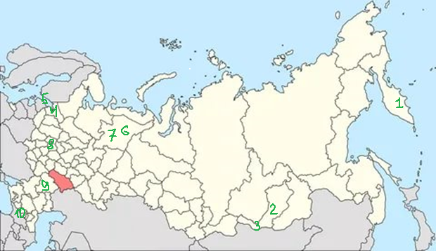

(0-10 баллов)

1. **Match the pictures with the names of the 7 wonders:**

|  |  |
| --- | --- |
|  | 1. the Valley of Geysers |
|  | 1. Lake Baikal |
|  | 1. Mount Elbrus |
|  | 1. Peterhof |
|  | 1. Stone Idols of Komi |
|  | 1. Mamayev Hill |
|  | 1. St. Basil’s Cathedral |

1-d,2-g,3-e,4-c,5-f,6-a,7-b.

(0-7 баллов)

1. **Look through the text and fill in the gaps:**
2. The valley of geysers is situated on *Kamchatka Peninsula*.
3. The valley of geysers is the second *largest concentration of geysers* in the world.
4. Lake Baikal is *deepest lake* in the world.
5. Baikal is often called *“Pearl of Siberia”*
6. Peterhof is *perhaps St. Petersburg most famous and spectacular* imperial estate.
7. Peterhof was supposed to rival the famous gardens of *Versailles*.
8. Stone Idols are the *geological* wonder in Komi Republic.
9. Stone Idols serve as a source of *legends and esoteric experiences*.
10. St. Basil's Cathedral is situated in *the very centre* of Moscow.
11. The Cathedral is symbolic of the *unique position* of Russia.
12. Mamayev Hill commemorates the *Battle of Stalingrad*.
13. Mount Elbrus is located in the western *Caucasus mountain* range.
14. Mount Elbrus is considered the *highest mountain* in Europe.

(0-13 баллов)

***Максимальное количество баллов – 30.***

***«Отлично» - 29-30 баллов,***

***«хорошо» - 25-28 баллов,***

***«удовлетворительно» - 16-24 баллов,***

***«неудовлетворительно» - 0- 15 баллов.***